## horizontal line



Solana Token Launchpad

23.05.2024

# Introduction

# Project Functions

# Live Test

# Introduction

The solana blockchain is well-suited for token launches due to its scalability, high throughput and low transaction fees compared to other blockchains.

With the explosive growth of decentralized finance and the rise of Solana as a leading blockchain platform, launching your own token on Solana has become more accessible but more challenging at the same time than ever.

But as to the fact that there are hundreds, if not thousands MEV bots exist and run in background to make arbitrage and get the maximum amount of Sols when the opportunity like creating openbook market and pool occurs, taking the safe and reliable route to launch tokens is vital for the success and bright future of released tokens.

Usually MEV bots, which is the natural enemy of successful token launch, work in the way of intercepting between Front-run, victim and Back-run transactions and making profits by following the rule of buying first and selling right after the victim.

In the same way, sniper bots have always made trouble for token creators by buying up large amounts of chips at the opening of new token pairs in IDO(Initial Dex Offering).

And Here is the part that our project comes into play - to prevent token issuers from having the result of vacant liquidity and constantly falling candlestick charts on dexscreener.

The project uses Jito’s bundle trading feature, which allows for the creation of liquidity and token purchases simultaneously on the Raydium platform.

The Jito Bundle emerges as a breakthrough solution within the Solana ecosystem, making it possible for traders to execute multiple transactions in one bundle.

These bundles are carefully designed lists of transactions that ensure sequential and atomic execution, thereby enhancing the efficiency and reliability of transaction operations.

All the functions and features in our project like creating tokens, creating openbook market and creating pool and initial buy and dispersing, selling and collecting tokens are realized using Jito bundling and this makes it the perfect and safe place to successfully launch tokens and guarantee the profit.

# Project Functions

## Token Creator

You can create your own tokens by providing certain characteristics of tokens including name, symbol, metadata, total supply and decimals.

It will create a fully customized token as to your instruction using Jito Bundle.

## Create Openbook Market

You can create your own openbook market by providing certain characteristics of the openbook market including token address, quote address, minimum order size and minimum price tick size.

It will create a fully customized openbook market as to your instruction using Jito Bundle.

## Buy & Sell

This is the main function of the project.

First you can generate a certain number of wallets which will be used for the other functions later and you can download a csv file containing public and private keys of those wallets.

Zombie wallet is responsible for dispersing sols, which are added to the additional sols used to pay for transaction fees and bundle tips, to the main wallets.

Amongst generated wallets, the first four are the main wallets and they take part in buying tokens initially at the same time with the pool creation and dispersing tokens to the other child wallets aimed to increase volume size of the trade.

Next you can create the pool of your own token and quote token and let the main wallets buy tokens from that pool by specifying token amount and sol amount that will be paired together.

The token issuer can then sell tokens at the right time according to the status of the pool to make the most profit and collect all sols from all the generated wallets.

All these transactions are included individually in one Jito bundle and treated atomically and executed sequentially making it impossible for the other sniper bots to intercept.

## Volume Bot

After the token issuer created a pool, he can make it more tradeable to let the other bots or users buy his tokens by achieving a greater volume size of the pool.

This is the part that our volume bot function is in charge of.

By utilizing this function adaptably to the market circumstance, the token issuer can boost his self-made token price and create an opportunity to make a big hit and collect an incredible amount of sols from his reasonable investment.

Our team is now in the process of developing this function and sooner or later it will be deployed to the project.

## Remove Liquidity

You can remove liquidity of the pool you created by providing token address, quote address and the percent of liquidity to remove.

It will then remove liquidity as to your instruction using Jito Bundle.

# 3. Live Test

## Bundle Transactions

We created our token named “bug” using the project’s Token creator function and created an openbook market with bug token and quote token ( Sol ).

All of these transactions occurred in the Jito bundle and you can view details of their Jito Bundles in the following.

**Token Creation Bundle:**

<https://explorer.jito.wtf/bundle/4aHz3wvKVM9PXk6Bj224mGf9FJQzGHg9zTR3XUTrk9m62ejhR3kFf89CD1a1aWb3KMDHjmqpUrWQkjPHV47Z2pN2>

**OpenBook Market Creation Bundle:**

<https://explorer.jito.wtf/bundle/99a256b93183244093f04ef14d1dd09da38c2b55b3ed16676970bec430d418c0>

**Disperse Sol Bundles:**

<https://explorer.jito.wtf/bundle/d6ddbd721b9c887b698906caf44375649875af1d20ddfc084b448c375cce10ab>

**CreatePool And Initial Buy Bundle:**

<https://explorer.jito.wtf/bundle/561660449c39924f26769097f02a446f08cb71e0cd91ee2ebca8212ff7416bee>

**Collect All Sol Bundles:**

<https://explorer.jito.wtf/bundle/5XzLUnmzgfj16DodRUJ6ajQSz9vQ1GR15nQEj5FNHaZEQH12Y3DvCUg1Y6tbxSymio2UQFjkXxNgMTHTBLbPxpeP>

## Profit and Loss Analysis

Finally Let’s continue to talk about the profit and analysis of our token launch using the project on Solana.

You can have a general view of profit and loss of our token launch in dextools and photon.

The url is :

<https://www.dextools.io/app/en/solana/pair-explorer/2pLjepYG7e2bqmTfxMDo3eUAKF8AQ8uA3adCEYaTR8tp?t=1716432063736>

<https://photon-sol.tinyastro.io/en/lp/2pLjepYG7e2bqmTfxMDo3eUAKF8AQ8uA3adCEYaTR8tp>

Let’s analyze the transactions in the pair of Bug token and Sol in dextools.

* We created a pool of 1 billion Bug tokens and 4 Sols.
* Our first main wallet initially bought Bug tokens with 0.7 Sol and the price of Bug token went up to 0.00000506 usd.
* Our second main wallet initially bought Bug tokens with 1.0 Sol and the price of Bug token went up to 0.00000708 usd.
* Our third main wallet initially bought Bug tokens with 1.5 Sol and the price of Bug token went up to 0.000026 usd.
* Our fourth main wallet initially bought Bug tokens with 2.6 Sol and the price of Bug token went up to 0.000027 usd.

All of the above transactions occurred in one Bundle so it never allowed any sniper to intercept in initial buying and get the most number of tokens in our wallets.

* Finally when the price of Bug token went up at the reasonable value and the sol amount in the pool got greatly larger then we removed the liquidity and got sols back.

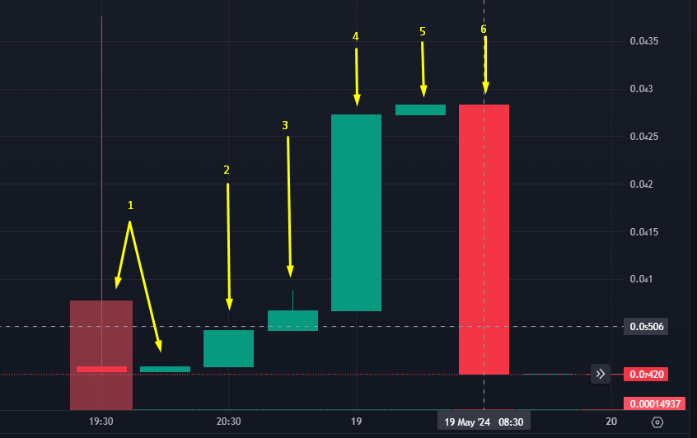

Now it’s time to discuss the profit and loss of our token launch.

We invested 4.00 sol for creating the pool and 0..7, 1, 1.5, 2.6 sol to initially buy.

Before this we wasted 0.45 sol for creating an openbook market, 0.3 sol for creating a pool and the sum of all the transaction fees and Jito tips is 0.2 sol.

So in total we invested

**Input : 4 + 0.7 + 1.0 + 1.5 + 2.6 + 0.45 + 0.3 + 0.2 = 10.75 sol**

And we got **11.03** sol by removing liquidity so the profit is

**Profit : 11.03 - 10.75 = 0.28 sol**

